-------------------------------------------------------Ansible--------------------------------------------------------------

**Can we skip the tasks in playbook? ----**tags in ansible

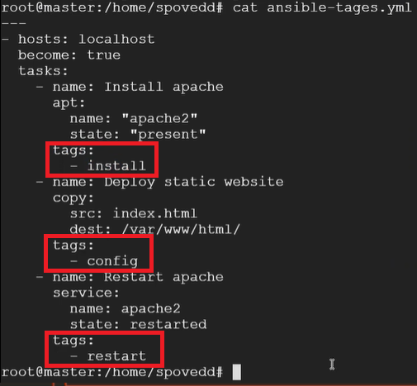

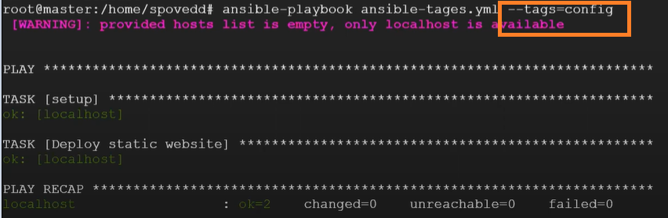

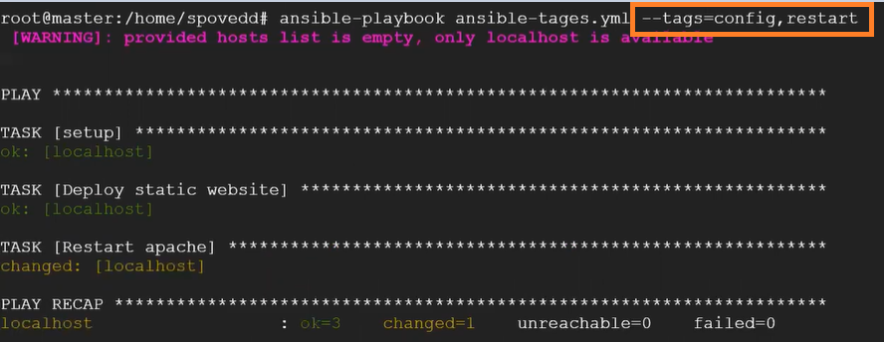

To skip the specific task out of n tasks;

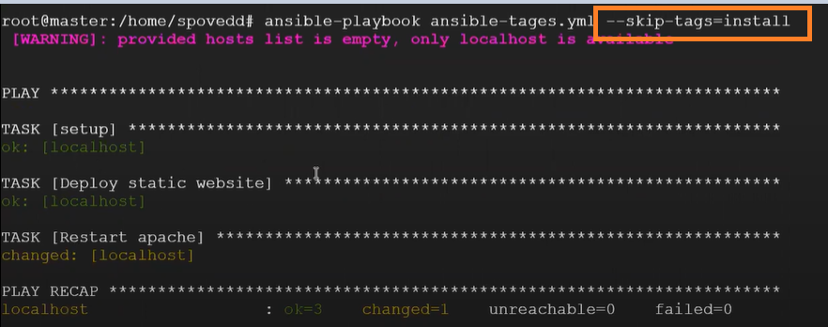

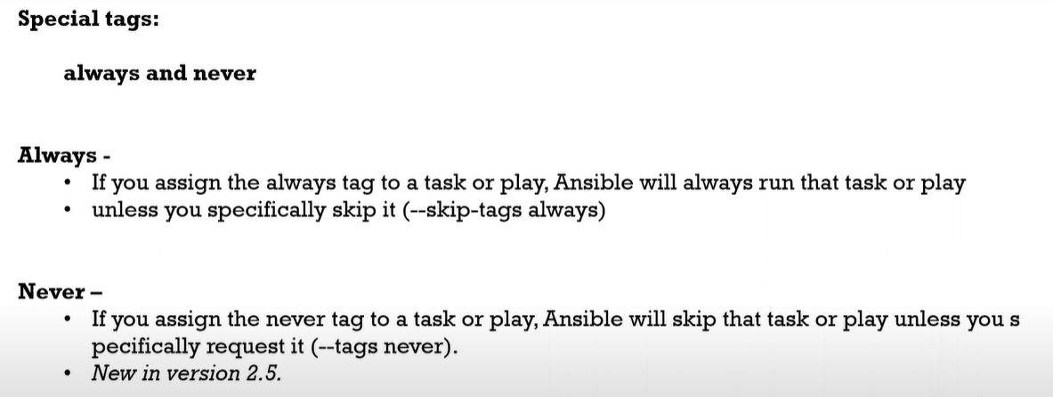

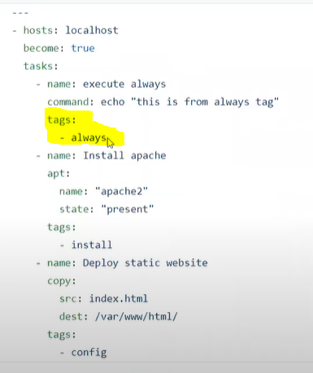

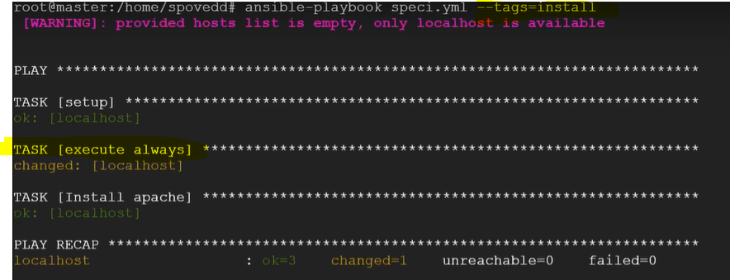

If you tell to skip that forcefully ,then it will not execute.

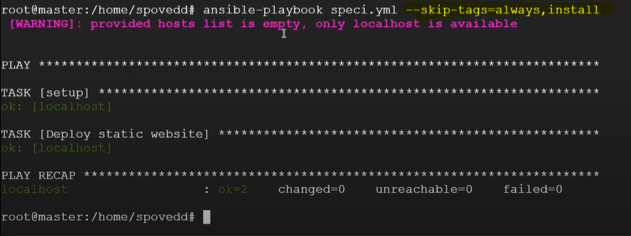

**Diff b/w file and template module?**

**Template module—**allows you to template a file onto a remote host using jinza2 template.

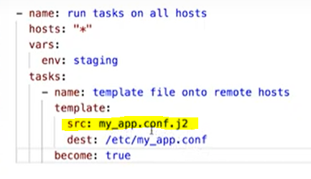

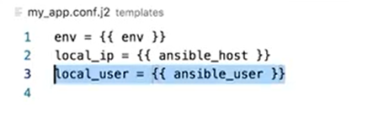

After execution:

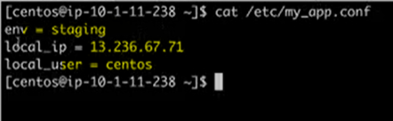

**File module**: 1) we can create/remove directories

2)we can create/remove files

**Diff b/w shell and command?**

With the example below ,shell command redirects the output to file(shell_output) whereas command module treates whole attribute as a command (Conditional operators will work)

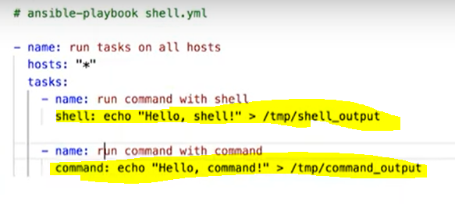

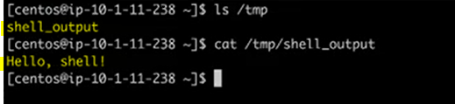

**Ansible directory structure?**

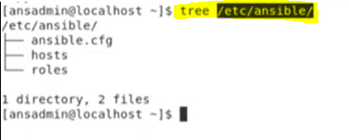

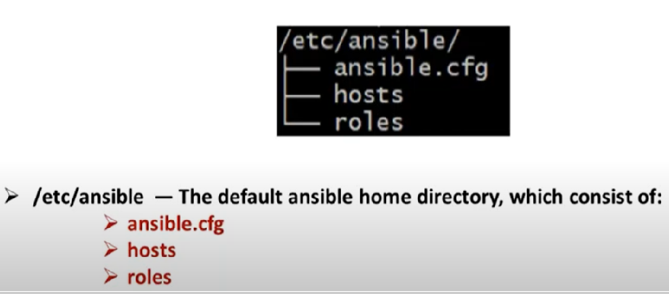

**Diff b/w Ansible and Terraform?**

Ansible—configuration/Deployment

(Skipping tasks,gathering facts,encrypt the playbooks,roles,depending upon the OS family,,grouping of hosts)

Terraform –infra provisioning ,statefile,backed,locking statefile

**Why we need ad-hoc ansible commands, scenario where you have used ansible ad-hoc command?**

Ans :: Adhoc commands are quick and easy ,but they are not re-usable.

Ansible all –I hostname –m **ping**

Ansible dev –I hosts –m **setup**

**When i need detailed logs on executing ansible playbook what option i need to use?**

Ans :: We can use verbose ( -vvv)

**what is ansible.cfg file?**

Usually Ansible pickups lots of default values from ansible.cfg file

It is located at /etc/ansible/ansible,cfg

We can define certain setting in ansible.cfg

1. Inventory

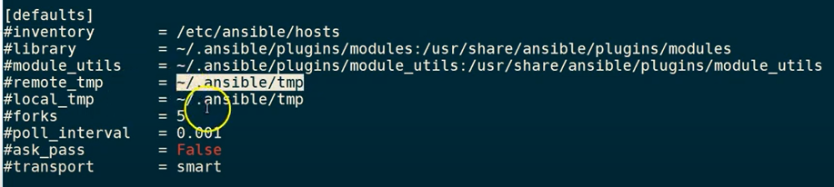

**what are the modules have you worked on? which module will you use for getting the file from node to master?**

Ans :: Copy,Fetch,Ping,Setup,Yum,Debug,Get_url,Expect,Template,File,Apt,command ,shell

Fetch==Node to master

Copy==Master to node

**Lets say i have a playbook which has 5 tasks in playbook, first 2 tasks should run on local machine and other 3 tasks should run on node?**

Ans :: Using multiple play we an achive this.

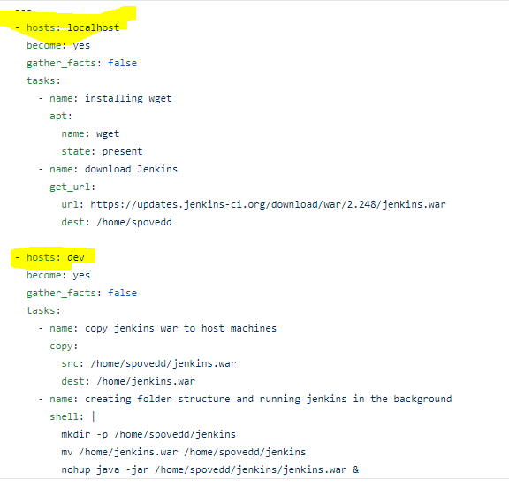



Ans ::

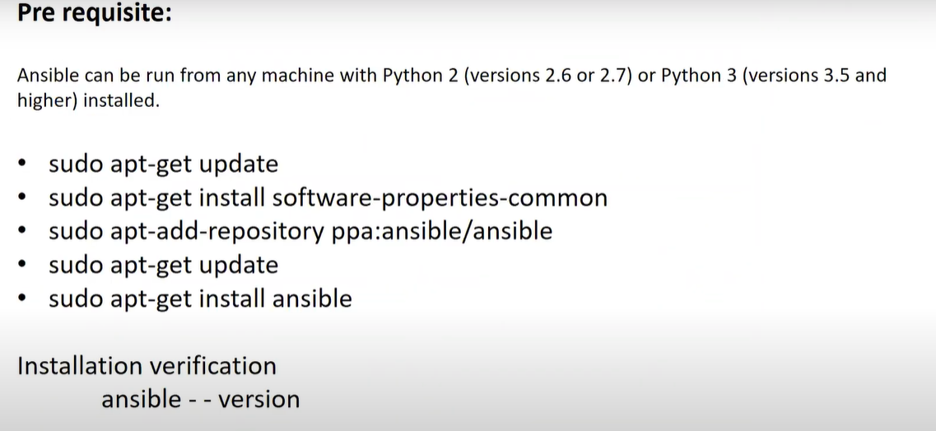

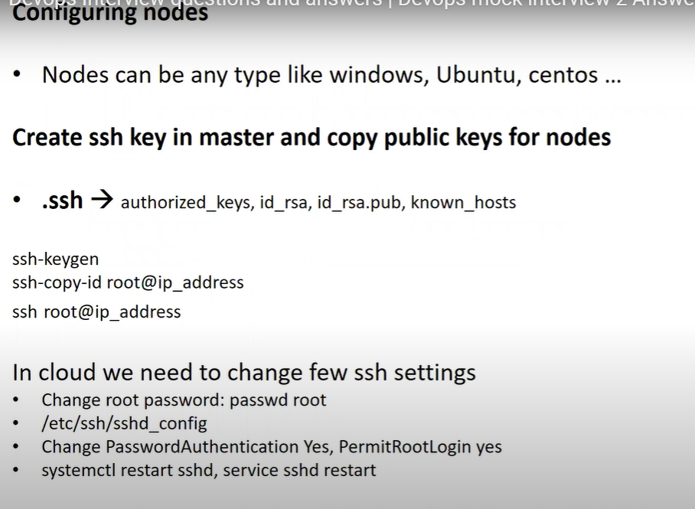

**What are ansible facts?**

Ans ::

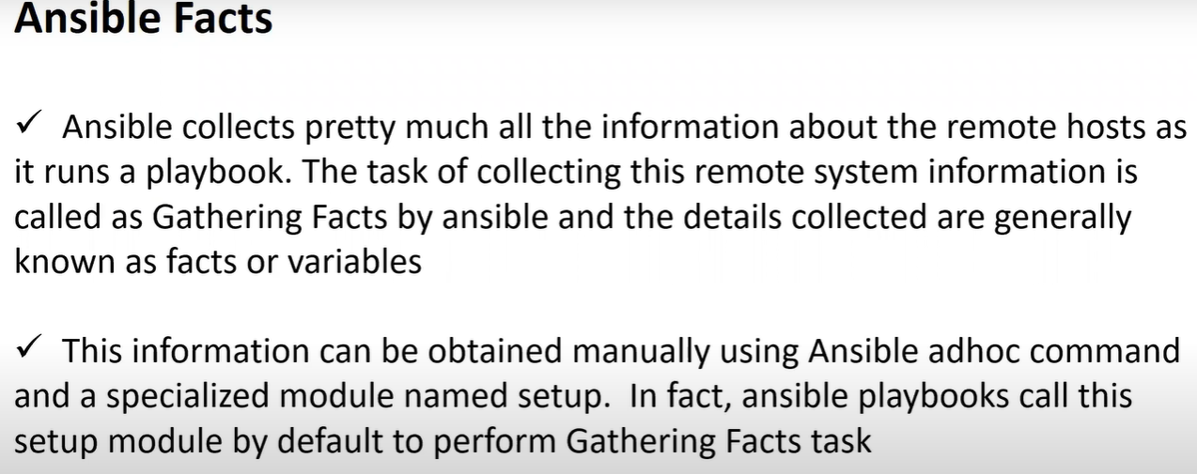



Ans :: No widows machine can’t be used as a master ,we can use it as a node.



Ans :: **Become :: yes or true**



Ans :: When to use the **fetch module** vs **copy module**

The **fetch module** is used when you want to move files from the remote host to the local host (i.e. **fetch a** file from the remote host). The **copy module** is used when you want to put files onto the remote host, or you want to **copy** files to another location on the remote host.

**Ansible galaxy ?**

**Can we store outputs of modules? –redirect or** use**register module**

9. How to declare one Yaml file inside another Yaml file?---include module

10. How do you know ansible work flow? ---Ansible tower

12. When u trigger a playbook what will happen in screen?

6. What is Ansible? Explain what are all the components?

3. Write a playbook for nginix?

6. What is inventory host file how you differentiate different host servers?

7. How to configure Dynamic inventory file?

1. Ansible Architecture and how its work?

2. What are the main advantages using ansible?

3. How will access list of ansible variables

**Playbook:**

-

name: Play1

tasks:

- name: Execute command 'date'

command: date

tags:

- verify date

- name: Execute script on server

script: test.sh

tags:

- execute script

- name: install httpd service

yum:

name: httpd

state: present

tags:

- install httpd

- name: start the service

service:

name: httpd

state: started

tags:

- start the service

- name: verify whether http is installed

raw: yum list installed | grep http > install.pkg

tags:

- verification

- name: update entry

lineinfile:

path: /etc/resolv.conf

line: 'nameserver 10.0.0.9'

- name: create a new user'

user:

name: web_user

uid: 1050

group: dev

---

- name: install nginx

hosts: all

tasks:

- name: install nginx on debian

apt:

name: nginx

state: present

when: ansible_os_family == "debian"

tags:

- install nginx on debian

- name: install nginx on REDHAT

yum:

name: nginx

state: present

when: ansible_os_family == "REDHAT"

tags:

- install nginx on REDHAT